Original chart from EIB-12 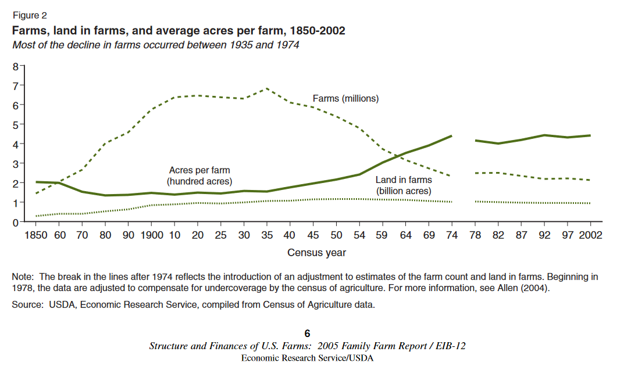

The underlying data (through 2007): THIS IS FROM R. HOPPE

|  |  |  |  |  |
| --- | --- | --- | --- | --- |
|  | No. of | Farmland | No. of | Farmland |
|  | farms |  | farms |  |
| 1850 | 1.449 | 0.293561 |  |  |
| 60 | 2.044 | 0.407213 |  |  |
| 70 | 2.66 | 0.407735 |  |  |
| 80 | 4.009 | 0.536082 |  |  |
| 90 | 4.565 | 0.623219 |  |  |
| 1900 | 5.74 | 0.841202 |  |  |
| 10 | 6.366 | 0.881431 |  |  |
| 20 | 6.454 | 0.958677 |  |  |
| 25 | 6.372 | 0.924319 |  |  |
| 30 | 6.295 | 0.990112 |  |  |
| 35 | 6.812 | 1.054515 |  |  |
| 40 | 6.102 | 1.065114 |  |  |
| 45 | 5.859 | 1.141615 |  |  |
| 50 | 5.388 | 1.16142 |  |  |
| 54 | 4.782 | 1.158192 |  |  |
| 59 | 3.711 | 1.123508 |  |  |
| 64 | 3.158 | 1.110187 |  |  |
| 69 | 2.73 | 1.062892 |  |  |
| 74 | 2.314 | 1.01703 |  |  |
| 78 |  |  | 2.479 | 1.029695 |
| 82 |  |  | 2.501 | 1.000738 |
| 87 |  |  | 2.337 | 0.978739 |
| 92 |  |  | 2.18 | 0.96398 |
| 97 |  |  | 2.216 | 0.954753 |
| 2002 |  |  | 2.129 | 0.938279 |
| 2007 |  |  | 2.205 | 0.922096 |

This is my latest chart, the one I use in Charting the Essentials, I gloss over the “break” and I supplement the Ag Census data with the latest annual survey data (as it state in the source):

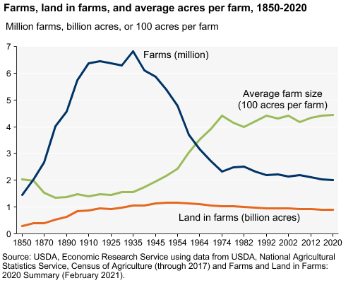

These are the underlying data. Note the shaded rows: I keep them in the data file, but I do not chart them. The intercensal points (2013-16 and 2018-20) come from *Farms and Land in Farms*)

|  |  |  |  |  |
| --- | --- | --- | --- | --- |
|  | Number of farms |  | Land in farms (billion acres) | Average farm size (100 acres) |
| . |  |  |  |  |
| 1850 | 1.449 |  | 0.293561 | 2.03 |
| 60 | 2.044 |  | 0.407213 | 1.99 |
| 1870 | 2.66 |  | 0.407735 | 1.53 |
| 80 | 4.009 |  | 0.536082 | 1.34 |
| 1890 | 4.565 |  | 0.623219 | 1.37 |
| 1900 | 5.74 |  | 0.841202 | 1.47 |
| 1910 | 6.366 |  | 0.881431 | 1.39 |
| 20 | 6.454 |  | 0.958677 | 1.49 |
| 1925 | 6.372 |  | 0.924319 | 1.45 |
| 30 | 6.295 |  | 0.990112 | 1.57 |
| 1935 | 6.812 |  | 1.054515 | 1.55 |
| 40 | 6.102 |  | 1.065114 | 1.75 |
| 1945 | 5.859 |  | 1.141615 | 1.95 |
| 50 | 5.388 |  | 1.16142 | 2.16 |
| 1954 | 4.782 |  | 1.158192 | 2.42 |
| 1959 | 3.711 |  | 1.123508 | 3.03 |
| 1964 | 3.158 |  | 1.110187 | 3.52 |
| 69 | 2.73 |  | 1.062892 | 3.9 |
| 1974 | 2.314 |  | 1.01703 | 4.4 |
| 78 | 2.479 |  | 1.029695 | 4.15 |
| 1982 | 2.501 |  | 1.000738 | 4 |
| 87 | 2.337 |  | 0.978739 | 4.19 |
| 1992 | 2.18 |  | 0.96398 | 4.42 |
| 97 | 2.215876 |  | 0.954753 | 4.31 |
| 2002 | 2.128982 |  | 0.938279 | 4.41 |
| 2007 | 2.204792 |  | 0.922096 | 4.18 |
| 2012 | 2.109303 |  | 0.914528 | 4.34 |
| 2013 | 2.10035 |  | 0.91403 | 4.35 |
| 2014 | 2.08244 |  | 0.913 | 4.38 |
| 2015 | 2.06389 |  | 0.912 | 4.41 |
| 2016 | 2.05534 |  | 0.911 | 4.42 |
| 2017 | 2.04222 |  | 0.900218 | 4.41 |
| 2018 | 2.0292 |  | 0.8995 | 4.43 |
| 2019 | 2.0234 |  | 0.8974 | 4.44 |
| 2020 | 2.019 |  | 0.8966 | 4.44 |